Blue Bear Property

Gem Grade Iolite and Museum Quality Quartz Crystals
Bulk sample permit has been sent in for approval in summer 2025.
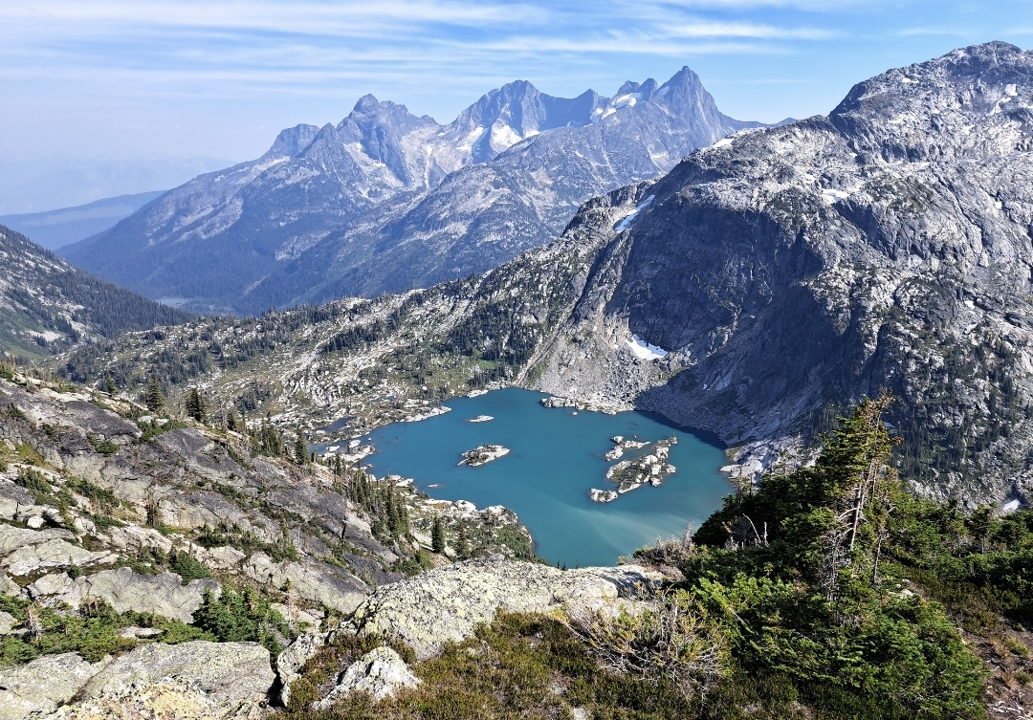

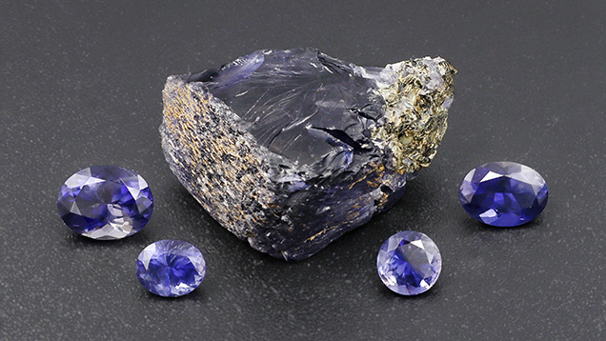
Figure 1: Rough and cut iolite from Blue Bear. From left to right, the faceted stones weigh 1.24, 0.48, 0.48, and 0.88 ct.
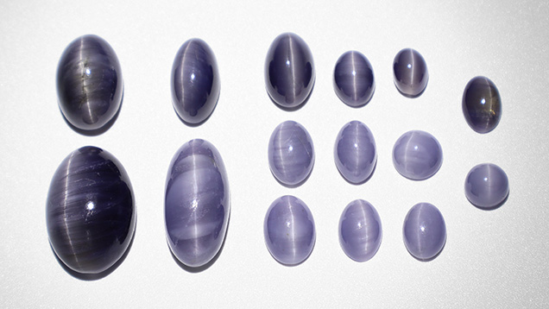
Figure 2: Chatoyant iolite cabochons from Blue Bear. The three largest stones weigh 12.02, 8.52, and 7.24 ct. The remainder weigh between 0.96 to 3.71 ct. Note the variation in color, where lighter-colored cabochons have a higher concentration of acicular inclusions.

Location and Access
The Blue Bear deposit occurs in outcrop at high elevation (approximately 2000–2400 m above sea level) 1–2 km south of Dickinson Lake and west of Horsefly Peak. The property is located on relatively steep slopes and very difficult terrain. The property can be accessed by hiking from the nearest logging road, but the Blue Bear claim is most easily accessed via helicopter since it is a substantially difficult hike with considerable elevation gain. Due to its high elevation, the Blue Bear locality is covered by snow except for one or two summer months (generally in August).
Occurrence Description
Violet-blue, strongly pleochroic cordierite occurs as subhedral to euhedral porphyroblasts in gedrite-cordierite-biotite-(±quartz) gneiss, and in quartz-cordierite veins (<10 cm thick) cutting these rocks (figures 5 & 6). The geographic extent of cordierite mineralization is currently unknown, and exploration in this steep, high-elevation terrain is ongoing. Cordierite crystals shown to the author averaged 5 cm across, and the largest crystal measured 11.3 cm long (figures 3 & 4). Cordierite crystals vary from anhedral to euhedral. Most large euhedral crystals are enveloped by biotite. The cordierite is highly fractured, translucent to transparent, and locally contains zones suitable for production of polished gemstones. In some crystals (in part or in whole), the cordierite is moderately to heavily included by parallel acicular inclusions. Cordierite that is not of gem quality occurs in biotite-rich quartzofeldspathic gneiss in the area.
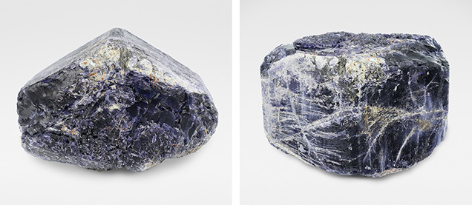
Figures 3 & 4: Large, euhedral cordierite crystal containing facetable and cabochon-quality sections. Note the deformation-induced fractures visible on prism faces in the photo on the right. The crystal measures 11.3 cm wide
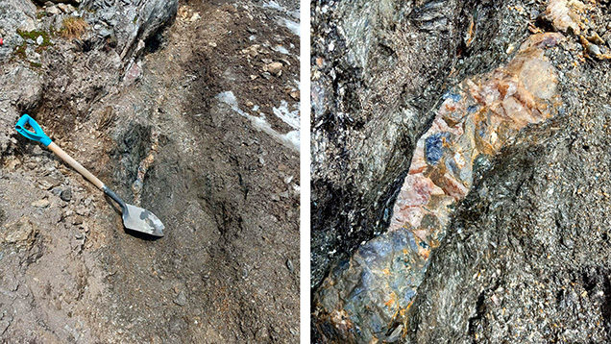
Figures 5 and 6: Cordierite-bearing quartz vein (approximately 10 cm wide) cutting gedrite-cordierite rocks at the Blue Bear occurrence.
Potential for Future Production
Beautiful, faceted stones, generally smaller than 2 ct and up to 4.76 ct (so far), have been produced in very small quantities from the Blue Bear property, and attractive cat’s-eye cabochons up to 12 ct have come from Blue Bear. Iolite was only discovered recently at Blue Bear, and the area has been minimally explored. Further exploration at Blue Bear has the potential to yield new iolite-producing zones.
Standard Gemological Properties
Cordierite from Blue Bear is very strongly pleochroic, showing three different colors in different orientations: dark saturated violet-blue, medium-light blue-gray, and light gray-yellow with low color saturation. Specific gravity values for the two largest iolite gemstones of each variety were 2.60 (faceted), and 2.59 (chatoyant cabochon). Refractive indices were measured on one faceted stone. The refractive index value is 1.538–1.548.

Table 1: Average chemical composition (in WT %), measured with EPMA.
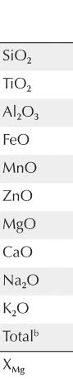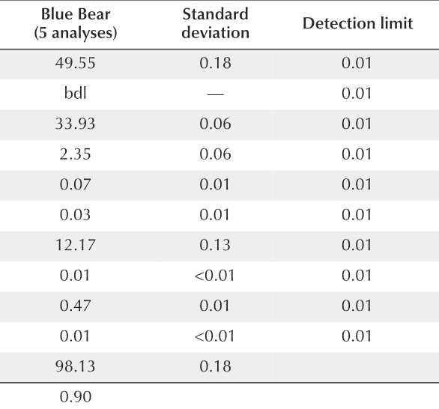
*bdl = below detection limit
Properties of Cut Stones
Faceted Stones. When correctly oriented to maximize the violet-blue color, faceted iolite stones show a beautiful, saturated violet-blue color that is of medium lightness in stones in the half-carat range, while dark in stones of approximately 1 ct.
Cabochons. Cat’s-eye cabochon samples consist of translucent cordierite containing abundant parallel acicular inclusions. They were cut with the base perpendicular to the grayish yellow axis of the cordierite. The stones are therefore grayish yellow if backlit through the base. They display a distinct chatoyant band perpendicular to the long axis of the acicular inclusions that is visible even in diffuse indoor and outdoor lighting conditions. The cabochons occur in two color varieties: dark grayish blue-violet with a light gray cat’s-eye, and light gray-blue with a very light gray cat’s-eye. Darker cabochons contain a lesser amount of acicular inclusions and are more transparent than the lighter, more heavily included cabochons. The strength and sharpness of the cat’s-eye is identical in the dark and light varieties.
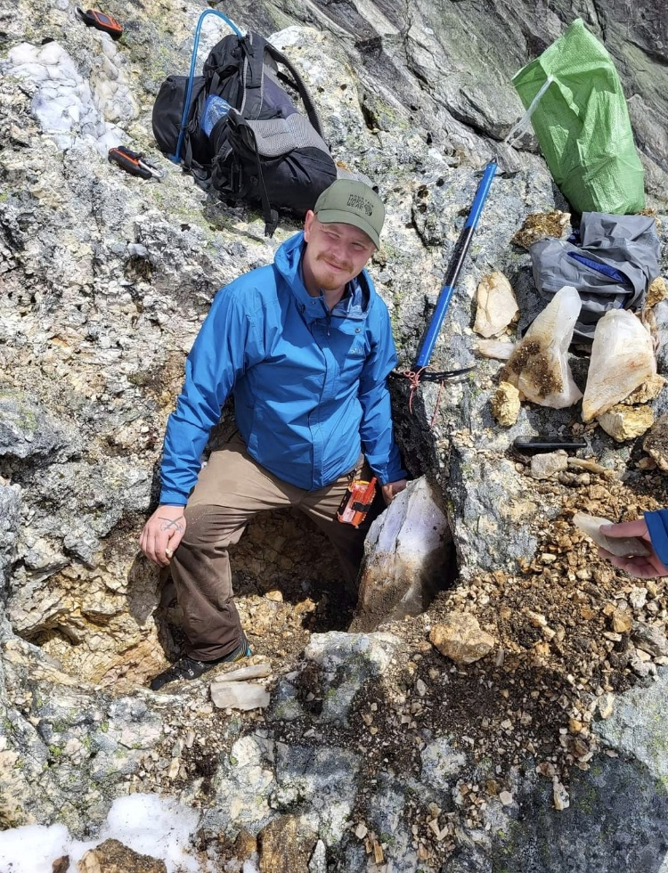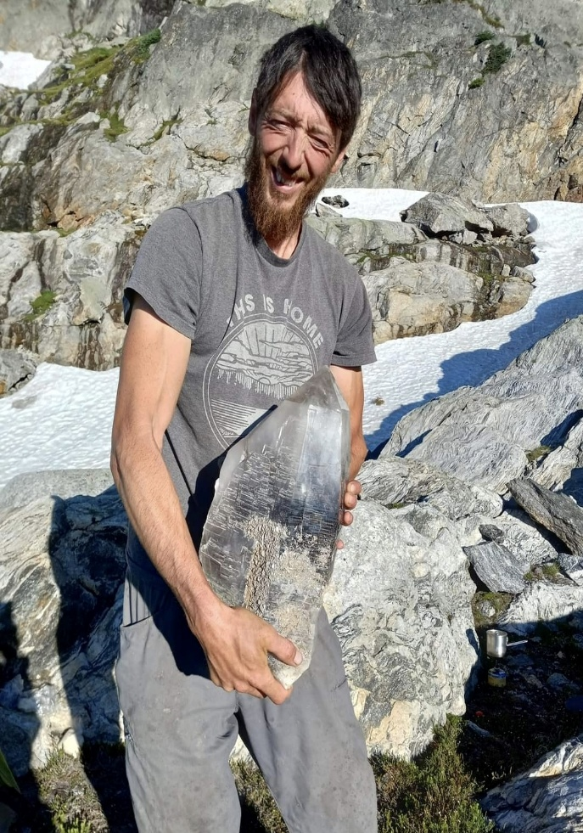
Figure 7: Pocket with massive museum Figure 8: Blue Bear discoverer Herb Hyder holding
quality quartz crystals. A 73 lb smoky quartz crystal.
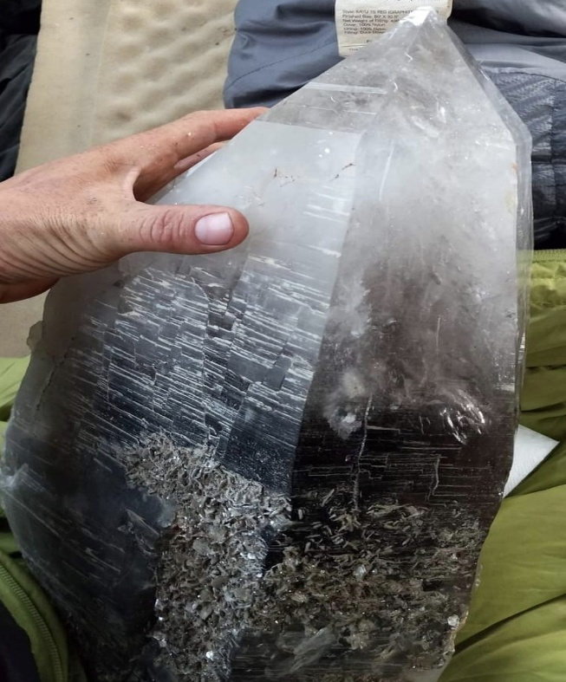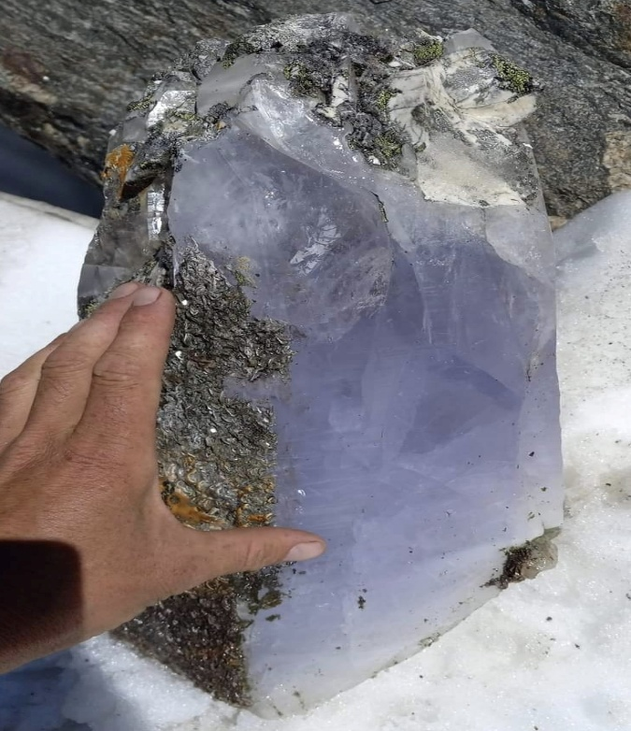
Figure 9: Close up of smoky quartz. Figure 10: Rare blue quartz crystal.

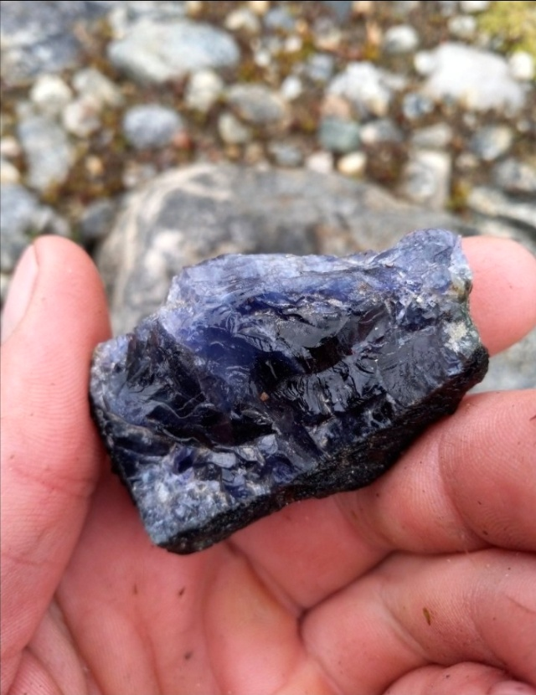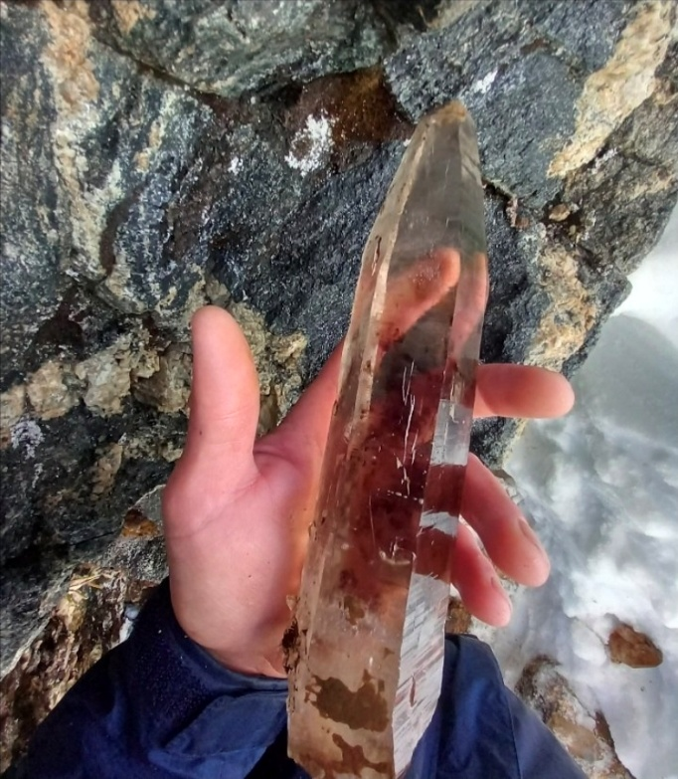

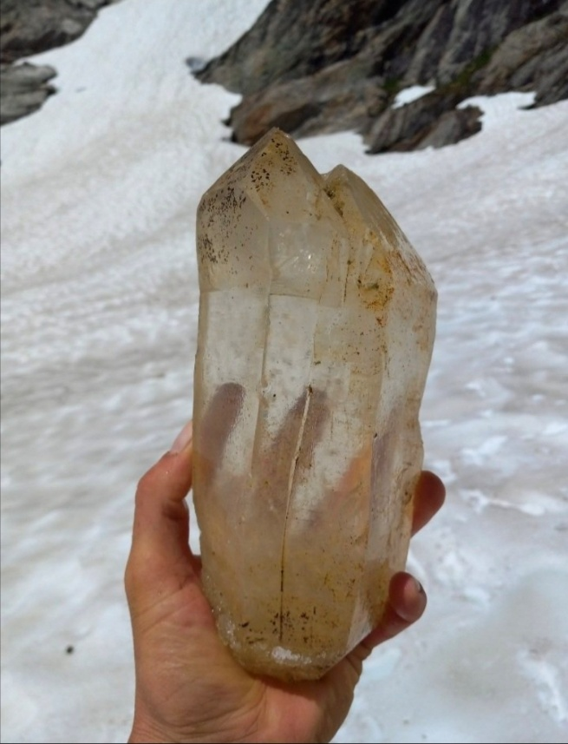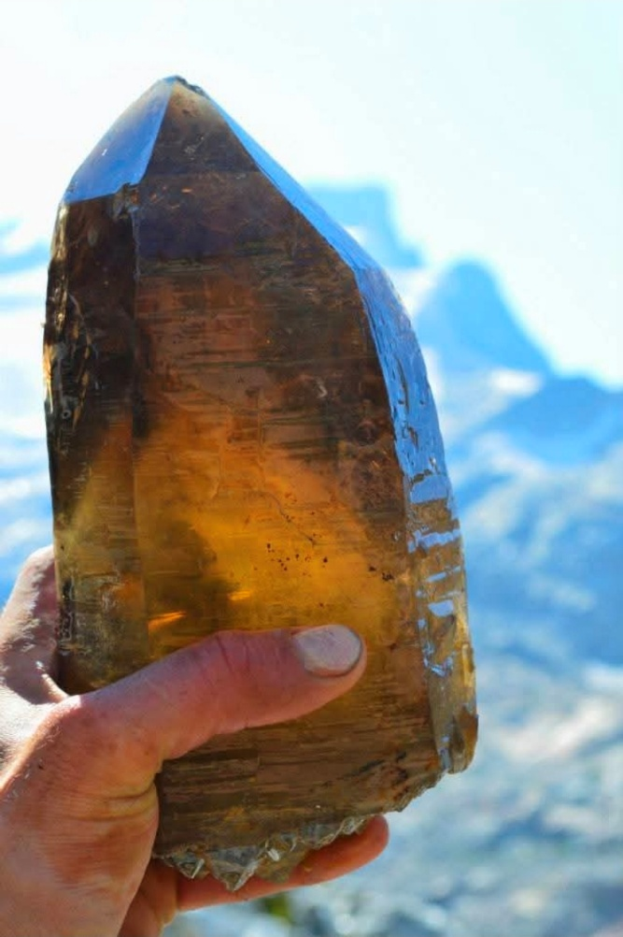

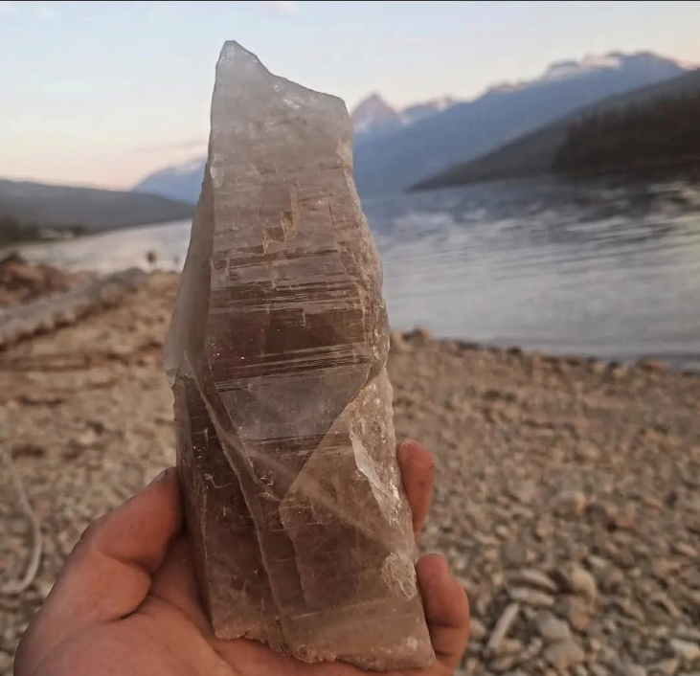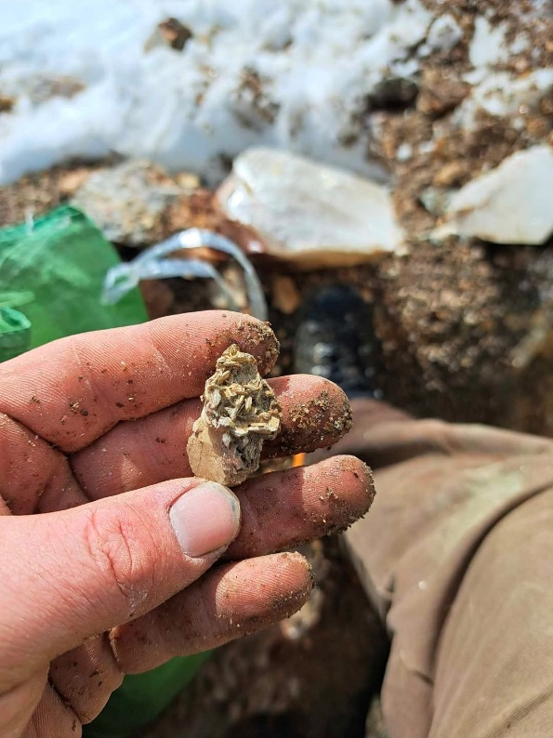
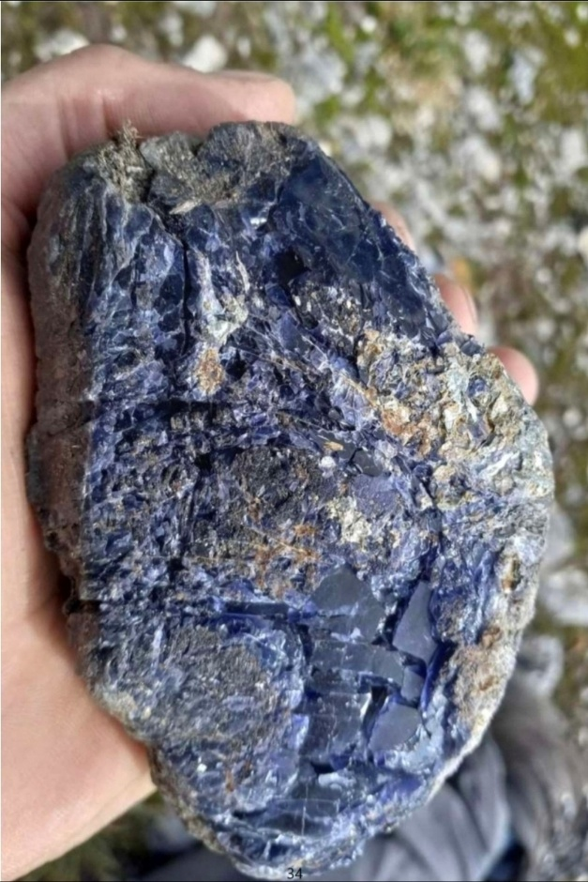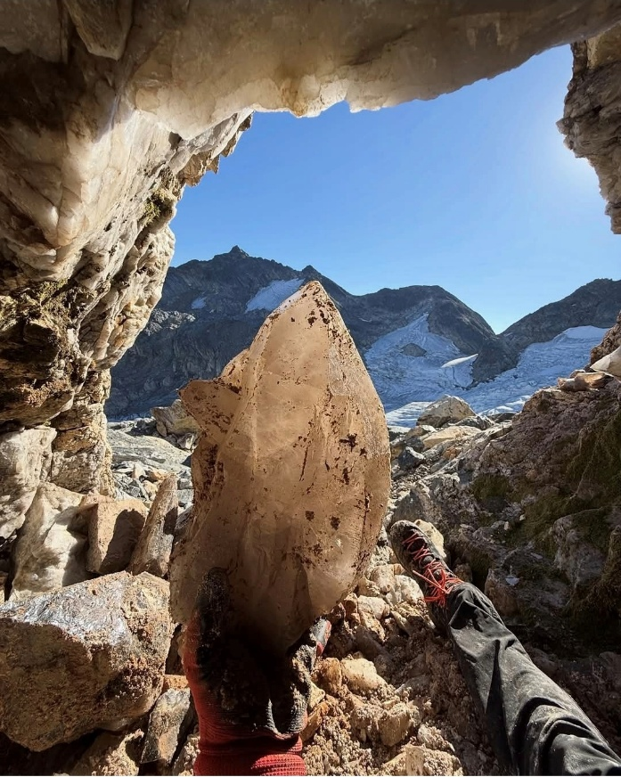

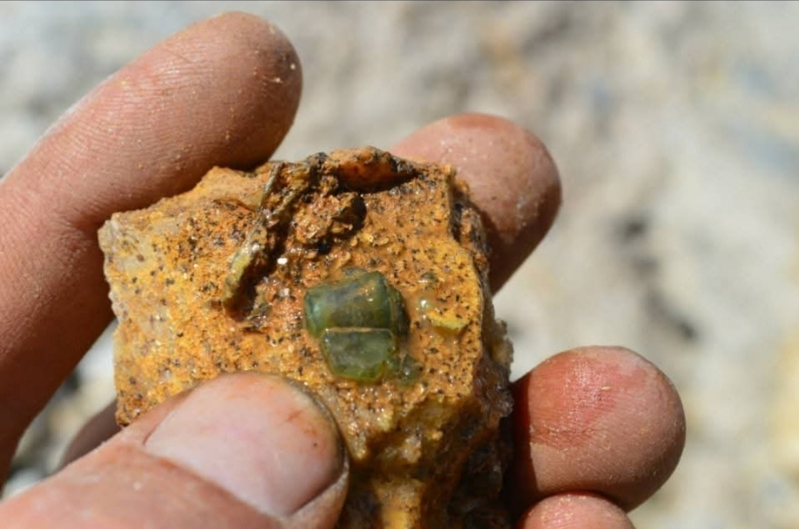

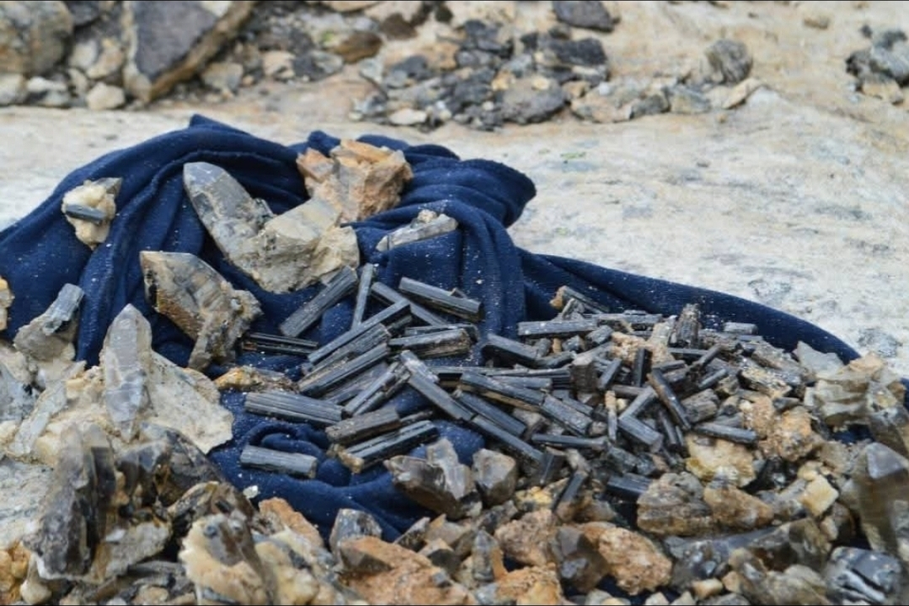

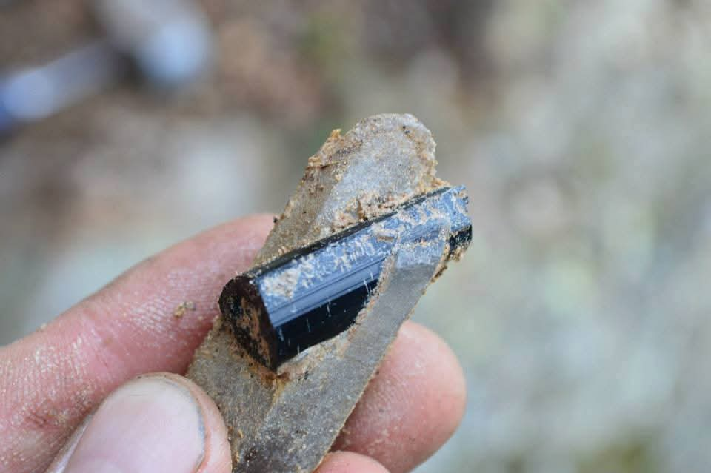

This property is offered for sale by way of cash or working option to purchase.
Preference given to companies willing to fund further exploration.
For more information, please contact:
Micheal Langille (250) 353-1723 riverroseresourcesltd@gmail.com
River Rose Resources Ltd

View other available properties at: http://www.riverroseresources.com

